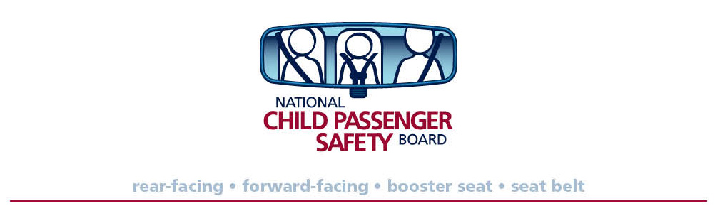

Pre-Approval Form for Category 1 and 4 CPS CEUs

This is optional.

Do not submit multiple forms for the same event. Sessions may be submitted for review one time only.

TYPE or PRINT USING AN INK PEN

Contact name:
Daytime phone number:
Email address:
Fax number:
Mailing Address:

Circle one: In-person session (category 1) Online/Web Session (category 4)

Conference name:
Target audience:
Date of conference:

How will proof of attendance be provided to attendees?

Complete an information page for each session and submit with this cover page to fax (202) 393-2072 or kchausmer@safekids.org.

Forms should be received at least 2 weeks before the event.

Requests will be reviewed and a response will usually be provided within three (3) business days of receipt via email.

Session Information Page
TYPE or PRINT USING AN INK PEN
Presenter name:
CPS Certification ID, if applicable:
Session title:
Length of session: _____

List session objectives:

Outline of presentation WITH TIMES (use additional pages, if necessary)

