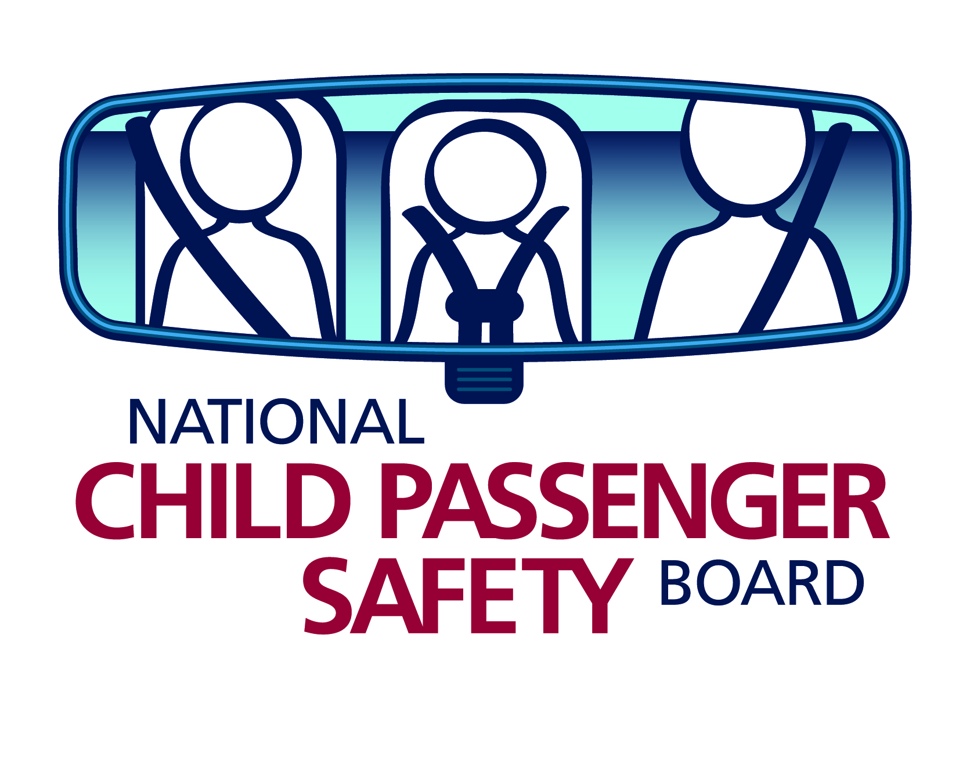
Quick CPST Reminders: Uncommon Situations

CPSTs (Child Passenger Safety Technicians) are faced with a wide variety of situations which may create challenge and intimidation. These quick reminders will help ease the fear and frustration when faced with uncommon situations.

Not Knowing a Correct Solution to an Unusual Situation
With the vast combination of car seats, vehicles and children, CPSTs are often faced with situations where there are no clear solutions. Once all of the facts have been gathered, you can use your available resources to present the parents with the various options. If you do not know what the appropriate options are, rely upon your basic tools to guide you including:

- Vehicle and car seat instruction manuals and phone numbers to vehicle and car seat manufacturers
- Certification program student manual
- Other CPSTs either on site or on the phone

Using a checklist form will enable you to capture the information needed in order to present the options to the parent.

Reminder: Tough choices are always made by the parent, not the CPST.

Unfamiliar Car Seat
No CPST knows every car seat on the market, nor should they be expected to. You will encounter a car seat you have never seen before. Don’t panic! Stay calm and remember the basics and start from the beginning.
- Familiarize yourself with the type of car seat it is.
- Read the labels on the car seat or the instruction manual to determine the age, weight and height parameters.
- Use the instruction manual to guide you with the correct installation and use of the car seat.
- If the car seat doesn’t have the instruction manual with it, utilize your other resources including websites and phone calls to the car seat manufacturers and other experienced CPSTs.

Just because a car seat looks different doesn’t mean it is any less safe or will be more difficult to use or install.

Remember the four steps:
- Selection (is this an appropriate seat for this child?)
- Direction (rear-facing or forward-facing?)
- Location (which seating positions in the vehicle can the seat be installed in?)
- Installation (seat belt or LATCH? Where’s the correct belt path? Are there lock-offs or is a locking clip needed?).

Once you demystify the unfamiliar features of the car seat, you will be more comfortable and confident teaching parents and caregivers how to use it correctly.

Tip: Visit a car seat retailer or manufacturer’s websites regularly to learn about the new models of car seats available.

Using a Locking Clip or Belt-Shortening Clip
With the increased number of seat belt systems that pre-crash lock and car seats that have built-in lock-offs, the use of locking clips and belt-shortening clips is becoming less and less common. If you are faced with a situation that may need a locking clip or a belt-shortening clip, remember these tips:

Locking Clip
- Used only on a continuous loop lap and shoulder seat belt – never on a lap-only belt!
- Used with a retractor that does not pre-crash lock
- Used with a latchplate that does not lock
- Once the seat belt is buckled and pulled tight so the car seat does not move more than 1” from side to side or front to back, unbuckle the seat belt and place the locking clip within 1” of the latchplate
- A locking clip aids a latchplate that doesn’t lock

Tip: Pinch the seat belt webbing together for easy installation and removal of the locking clip.

Belt-Shortening Clip
- Used on either a lap-only seat belt or a lap and shoulder seat belt
- Used only with an ELR (Emergency Locking Retractor)
- Used only with a sewn-on latchplate
- Once the seat belt has been buckled, pull the excess slack into a loop, unbuckle the seat belt and place the belt-shortening clip on the retractor side of the webbing. Lock the loop by threading the webbing back through the belt-shortening clip.
- A belt-shortening clip aids a retractor that does not lock

Tip: The use of a belt-shortening clip should be a last resort. Consider an alternative seating position if possible.

Avoid Working Alone
The National Child Passenger Safety Certification Training Program (R 10/10) advises new CPSTs that, “As a new technician you should never work alone until you have built more skills and decision-making ability in the field. Even after years of experience, you should always try to work with another technician to help you make good decisions and then recommendations to the parents.”

Tip: Connect and network with other CPSTs in your area to work together when assisting families with their car seats.

