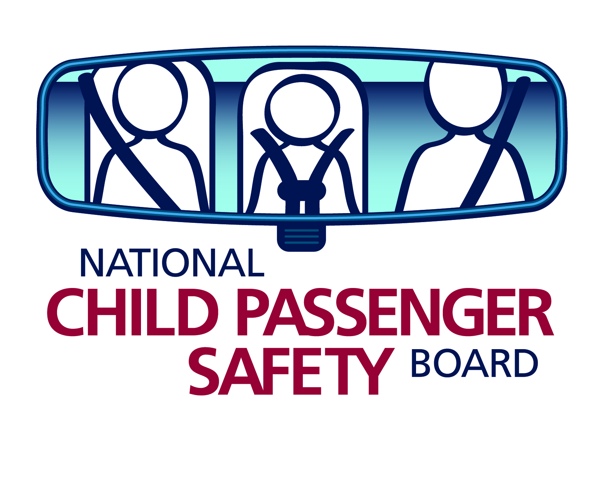

Key CPST Reminders
The best thing you can do for every family that comes to you for car seat education is to take your time.

Location
- Take time to observe the child, child restraint and installation choices.
- Take time to teach and provide updated information. Be thorough and take as long as you need so they learn, practice and can explain what you have taught them.
- Use a checklist! It will not only keep you on track, it is essential for your protection.

If you are not 100% sure about the car seat or installation, work with another tech, attend an update, and review the manuals.

- All children under age 13 should ride in the back seat.
- Never use a rear-facing car seat in a front seat with an active airbag.

Selection and Direction
- All children under age 13 should ride in the back seat.
- Never use a rear-facing car seat in a front seat with an active passenger airbag.
- Rear-facing (RF): Babies should ride in a rear-facing position to protect the spine and neck. Babies who have outgrown the infant-only child restraint (CR) by size should switch to a convertible CR and use it rear-facing up to the highest height or weight (usually 30-45 pounds) permitted by the manufacturer.
  - At a minimum, children MUST be age 1 and 20 pounds before facing forward.
  - The AAP recommends that children ride rear-facing until the age of 2.
  - NHTSA and Safe Kids recommend rear-facing as long as possible, using a rear-facing car seat until he or she reaches the top height or weight limit allowed by the manufacturer. This may be beyond 2 years of age.
  - RF: A child is too large for the CR when the child’s head is within 1 inch of the top of the rear facing CR or he exceeds CR weight or height limits.
- Forward-facing (FF): Once the upper limits of a FF harness are reached, the child can move to a belt-positioning booster. The child is too tall if their ears are above to top of the CR or their shoulders are above the top harness slots.

Harness
- Harness straps must pass the “pinch” test: when the buckled straps are pinched at the shoulder, there should be no slack or extra webbing.
- The harness retainer clip must sit at the child's armpit level, and the straps must be threaded properly through the clip.
- Rear-facing CR harness straps should pass through the slots at or below the child's shoulders according to manufacturer’s instructions.
- The forward- facing CR harness straps should pass through the slots at or above the child's shoulders according to manufacturer’s instructions.

Installation
- Tether, tether, tether to improve FF crash performance!
- LATCH or Seat Belt? Both are equally safe when used correctly. Do not use both the lower anchors and seat belt at the same time unless approved by the manufacturer (mostly in booster mode).
- FF harnessed CR? - Use a top tether according to manufacturer instructions, whether using the seat belt or LATCH, up to the weight limit of the tether anchorage in the vehicle. You can find this either in the vehicle owner’s manual or in the LATCH manual.
- Identify how the seat belt system locks. Test to be sure it stays tight and locked.
- Using LATCH? Be sure the seating position is approved. A common error is using LATCH in the center when not allowed by the vehicle manufacturer!
- Belts (lower anchor or seat belt) must pass through the CR exactly where and how the manufacturer directs.
- CRs must not move more than 1″ side to side or front to back when held at the belt path.

