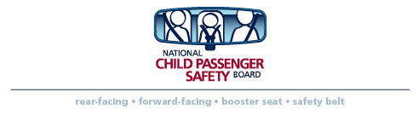
Map It Out – CPS Checkup Events
Prepared by the National Child
Passenger Safety Board
October 2013

Design your checkup event by using a grid, such as the one included with this document, to draw a map of the physical environment. This is helpful so you can fit your checkup in the designated space and so you can explain traffic flow, waiting areas, supply stations, etc. to those who will be working the event.
Remember SAFETY of staff, children and parents/caregivers is your main priority, so keep this in mind as you plan. Personalize your plan to include:
- Identify entrance and exits into the parking lot.
- Use directional arrows to show traffic flow.
- Mark median curbs.
- Draw checkup lanes – you do not necessarily need to stay within the white lines in the parking lot, but be sure to have plenty of traffic cones to manage traffic flow. Put a circle for each traffic cone. If possible, avoid having vehicles back up to exit.
- Identify the location for participant registration or the spot where the greeter will stop vehicles and direct them to the appropriate station.
- Indicate supply stations – where materials will be kept. Several stations may be needed to minimize foot traffic around vehicles.
- Identify businesses (stores, gas stations, restaurants) on the grid. This will help workers get a sense of direction for the parking area and will highlight areas of concern relative to the checkup.

“Map It Out” Sample Grid

