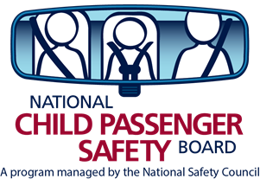

Do you wish there were more tech updates in your area?
Did you know you can set up an update?
Use this CEU toolkit and it’s as easy as 1-2-3! This toolkit contains everything you need to conduct a successful CEU Tech Update at a local store. This update provides technicians with hands-on experience as they learn about new seats and technologies.
Use elements of the toolkit to put together a local update for techs in your area. Be the CEU HERO!
In this toolkit you will find many sample resources.
- Planning
Letter to store manager asking for permission
Letter to techs explaining the CEU opportunity
CEU preapproval request form
- Let’s earn CEU’s!
Tips for a successful update
Sample activities and agendas
- Wrap up
Certificate of attendance
Thank you letters for the store and techs
Feedback form (Class Evaluation)
See? Everything you need in one place and ready to go!

